1. **Erase ESP32S3 T-Display:**
   1. Plug the USB cable while pressing the BOOT key:

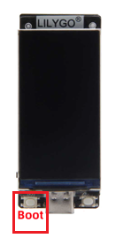

* 1. Open Flash Download tool

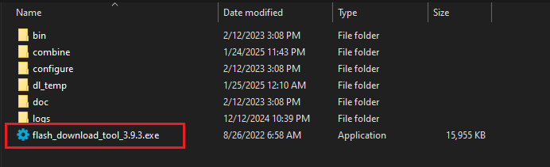

* 1. Select the right options

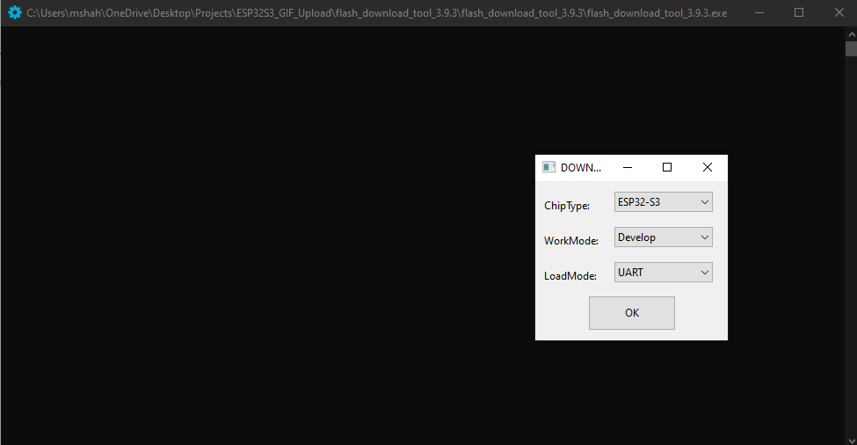

* 1. Click ‘ERASE’ button

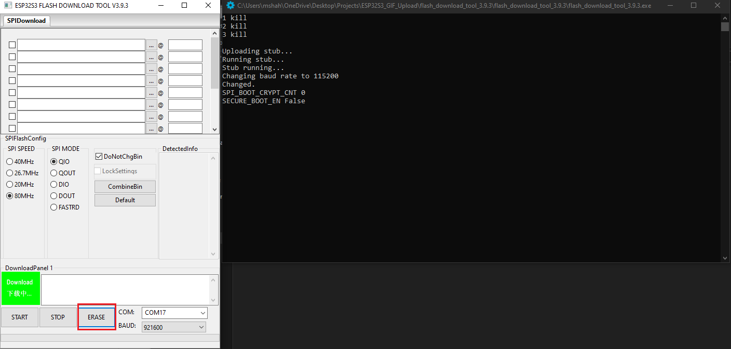

1. **Flash GIF_upload application**
   1. Select the required files, enter the memory address for each file and click the checkbox for each file
      1. 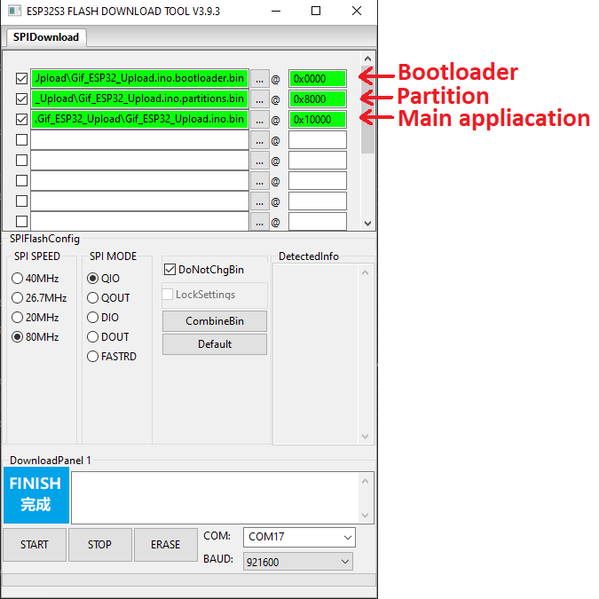
   2. Click ‘START’ button and wait for the files to flash

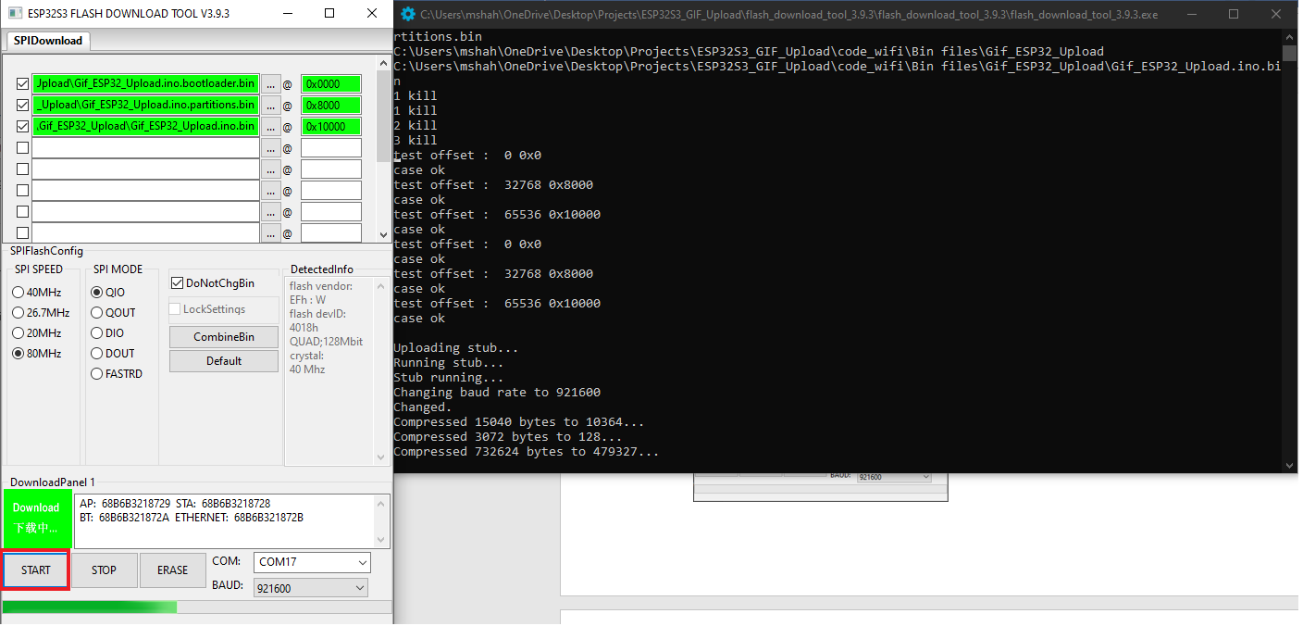

* 1. When the flashing is finished the status box will say “FINISH”

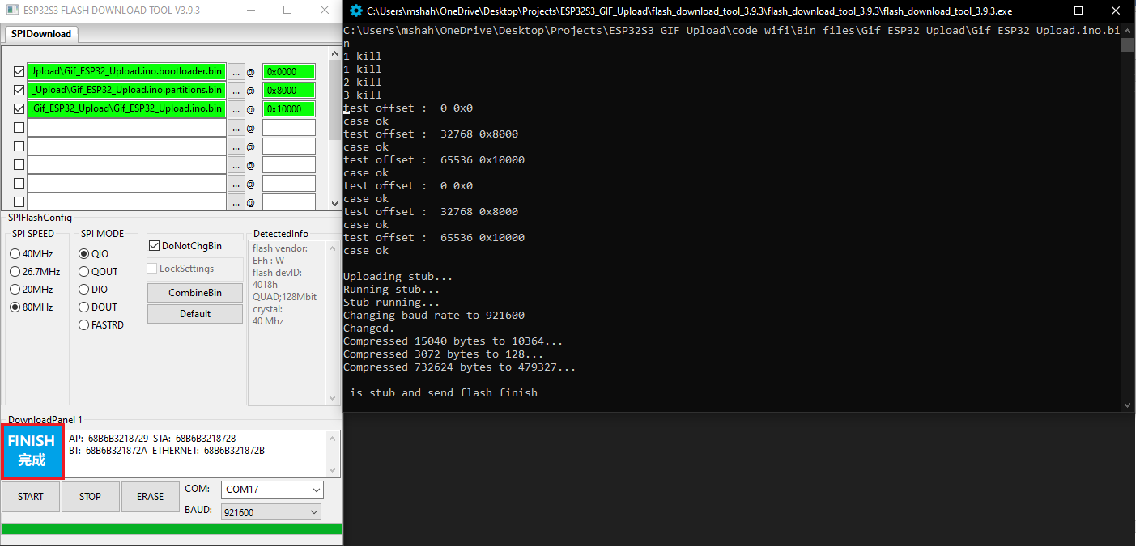

* 1. Disconnect ESP32S3 T-Display board and power it up again to run the application.